NAMA : ISMAIL NURHAPID JAMAL

NIM : 1207070060

KELAS : PCD TSEB

**HASIL OUTPUT PRAKTIKUM 5**

**PENGOLAHAN CITRA DIGITTAL**

1. **Brightness Grayscale**

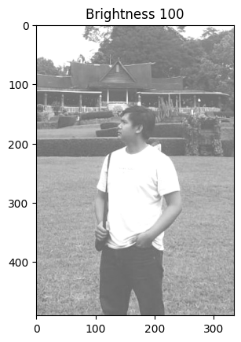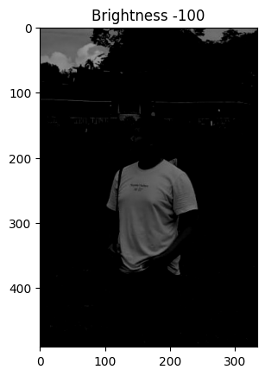

1. 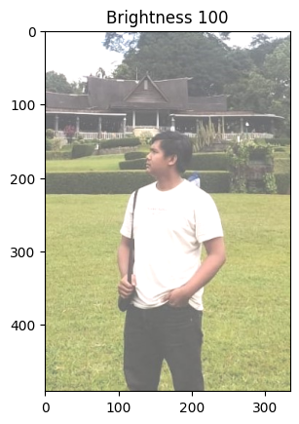**Brightness RGB**

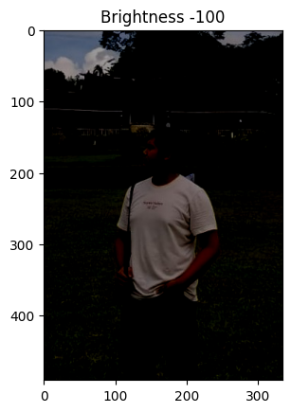

1. **Contras**

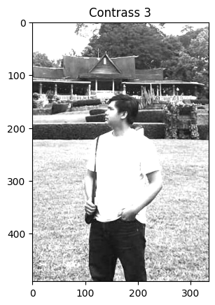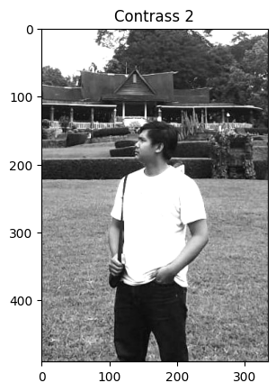

1. **Contras Autolevel**

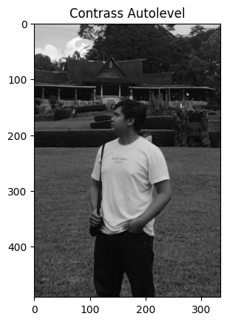

1. **Cropping Image**

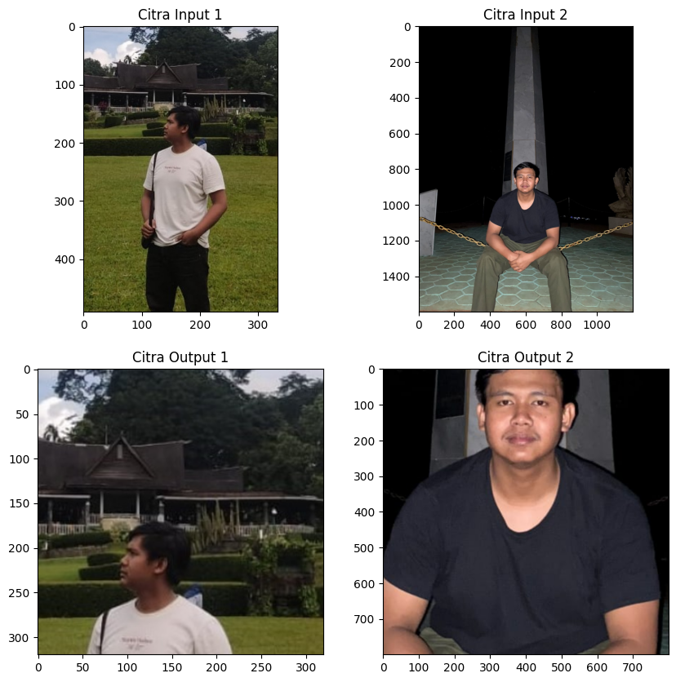

1. **Citra Negative**

